**CSCI 3330 Exam #2**

Write a program using HTML/CSS/JavaScript to create a user interface as shown in the following figure.

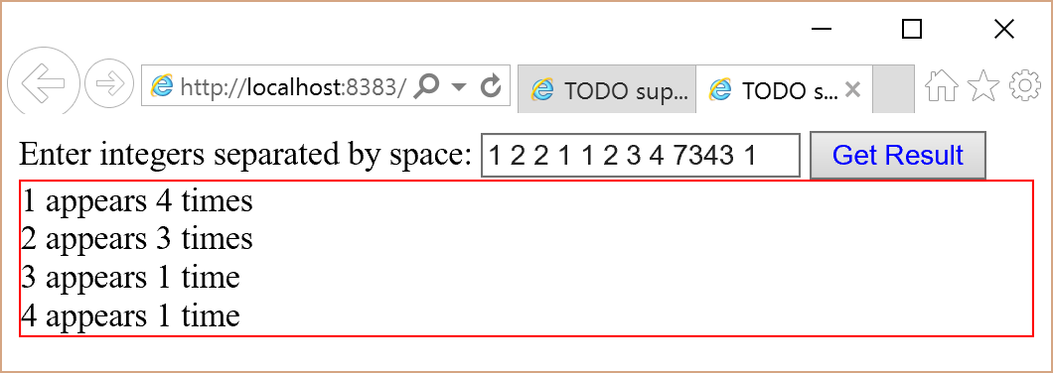

Usage: Enter the integers between 1 and 100 separated by space in a text field. Click the Get Result button to display the occurrence count of each number.

* If a number is not between 1 and 100, ignore this number.
* If a number occurs in the input, its count is displayed. Display each count on a separate line.
* If a number does not appear in the input, its count 0 is not displayed.
* If a number (say x) appears once in the input, display "x appears 1 time".
* If a number (say x) occurs more than once in the input (say 2 times), use "x appears 2 times".
* The red box is a <div>. Your result is displayed in the <div>.

**What to submit?** Copy and paste your entire file to PExam2 on LiveLab.